**IST 722 Assignment 6**

* Control Flow:

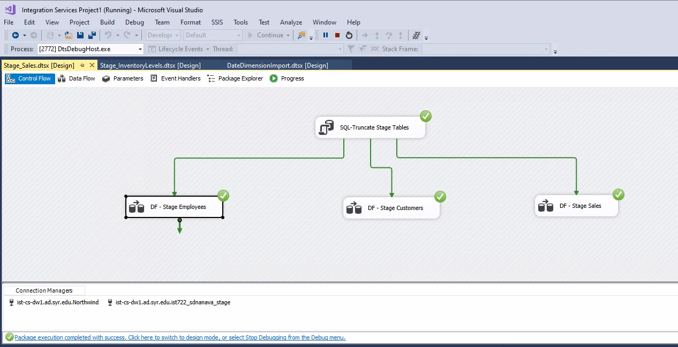

* Data Flow for Staging Employee data

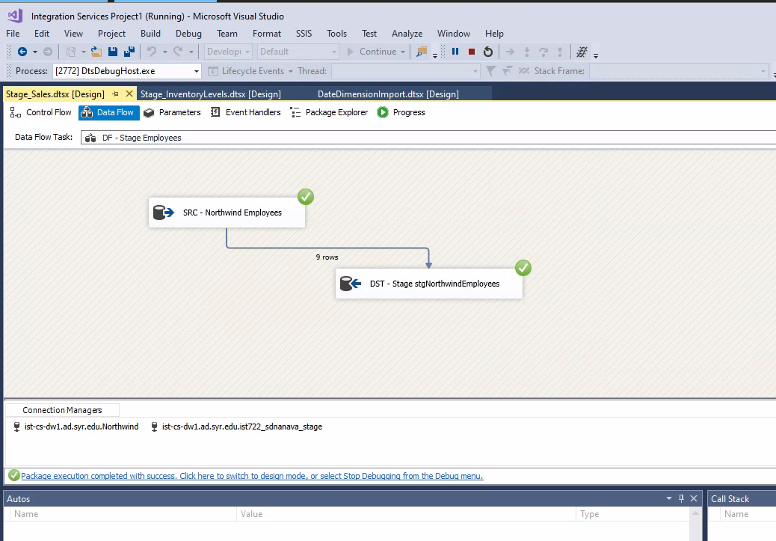

* Data flow for Staging Customers Data

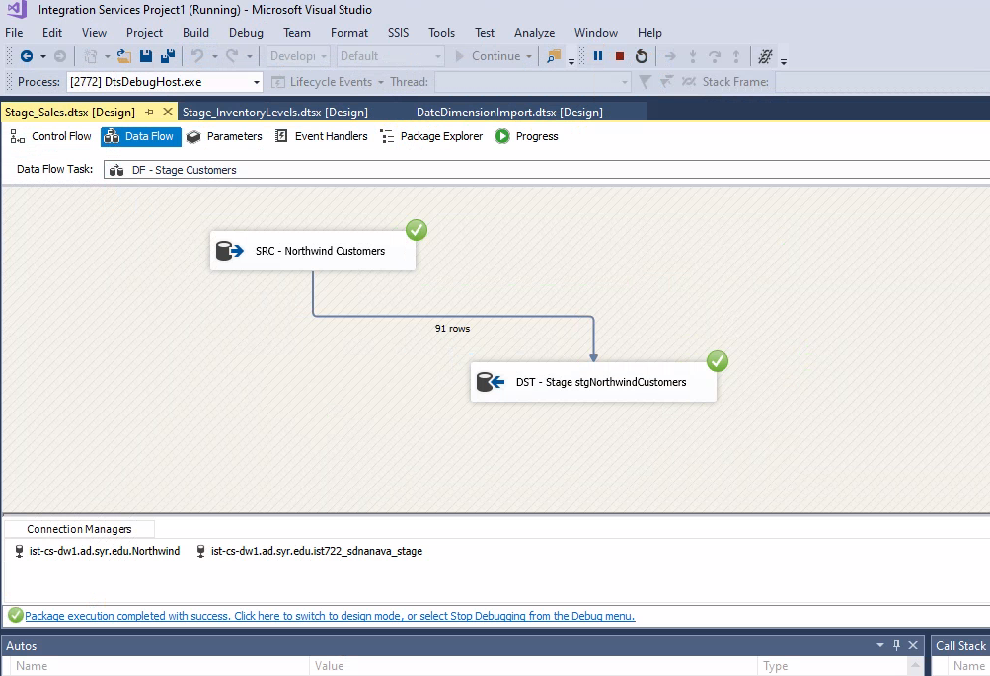

* Data flow for Staging Sales Data

